**Pastor's Reflections:**

Grace and peace to all of you,

Thomas Merton, an American Trappist monk, was a prolific writer. His family came to America from France after the first World War and he decided to stay in New England. He moved to Kentucky in 1941 to join the monastery just before WWII. If you want to know more about him, you can read his autobiography, *The Seven Storey Mountain*.

I want to share with you the beginning and ending of one of his published prayers that speaks to this season of transition we are journeying through together. In the midst of change it can feel like we are directionless or like we aren't sure what we're supposed to be doing. But I think Thomas Merton is onto something when he decides it’s best to trust that God is shepherding us even when we can't perceive it.

O Lord God,  
I have no idea where I am going,  
I do not see the road ahead of me,  
I cannot know for certain where it will end.

….

Therefore I will trust You always  
Though I may seem to be lost  
And in the shadow of death.  
I will not fear,  
For You are ever with me,  
And You will never leave me  
To make my journey alone.

- Thomas Merton

Blessings for the journey,

Pastor Sarah



**ORDER OF WORSHIP**

**ENTRANCE**

## GATHERING

WELCOME AND OPPORTUNITIESEdwina Hanson

## *INVOCATION CHORUS “*Blessed Assurance”* UMH 369 verses 1,2,3

*CALL TO WORSHIP

## *OPENING PRAYER In Unison

## *HYMN OF CELEBRATION *“Spirit Song” vs 1,2* UMH 347

**PROCLAMATION**

OLD TESTAMENT LESSON Exodus 16:2-4, 9-15 Julia Auner

CHILDREN’S MOMENT Rev. Sarah Jones

PRAYER FOR ILLUMINATION In Unison

## GOSPEL LESSON John 6:1-24-35 Rev. Sarah Jones

SERMON "What’s for Dinner" Rev. Sarah Jones

**RESPONSE TO THE WORD**

*AFFIRMATION OF FAITH Apostles’ Creed UMH 881

PRAYERS OF THE PEOPLE

INVITATION TO THE TABLE

CONFESSION AND PARDON

RETURNING OUR GIFTS Doxology UMH 95

**THANKSGIVING AND COMMUNION**

THE GREAT THANKSGIVING

SHARING THE BREAD AND THE CUP

*HYMN OF BENEDICTION *“Because He Lives” vs 1,2,3* UMH 364

*BLESSING AND BENEDICTION

POSTLUDE

*Please stand as you are able

**Calendar**

**Today: August 5th 2018**

Sunday School 8:45 am

Worship 10:00 am

Boondocks (Children’s Church) 10:15 am

**Upcoming:**

**Tuesday, August 7th**

Men's Coffee 7:30 am

**“**Sisters in Christ” 10:00 am

**Saturday, August 11th**

UM Men’s Breakfast 8:00 am

**Sunday, August 12th**

**“**Back to School Water Bash” after Worship

**Serving You Today**

Acolytes: Youth Volunteers

Pianist & Choir Director: Laura Bodenmann

Children’s Church: Volunteers

Sound Tech: Volunteers

Nursery: Frances Rios

Ushers: Gary Christian

Dustin DeRoche

Greeters: Jean Christian

Katie DeRoche

Pastor Rev. Sarah Jones

**Flowers:** Ted Johnson

*“In honor of Gladys Johnson’s birthday”*

**Flowers next week:**

There are many open dates in August and September on the Flower Calendar. Please share your garden flowers with us. You may want to select a special date and put the flowers "in memory or in honor of a special event or person.”

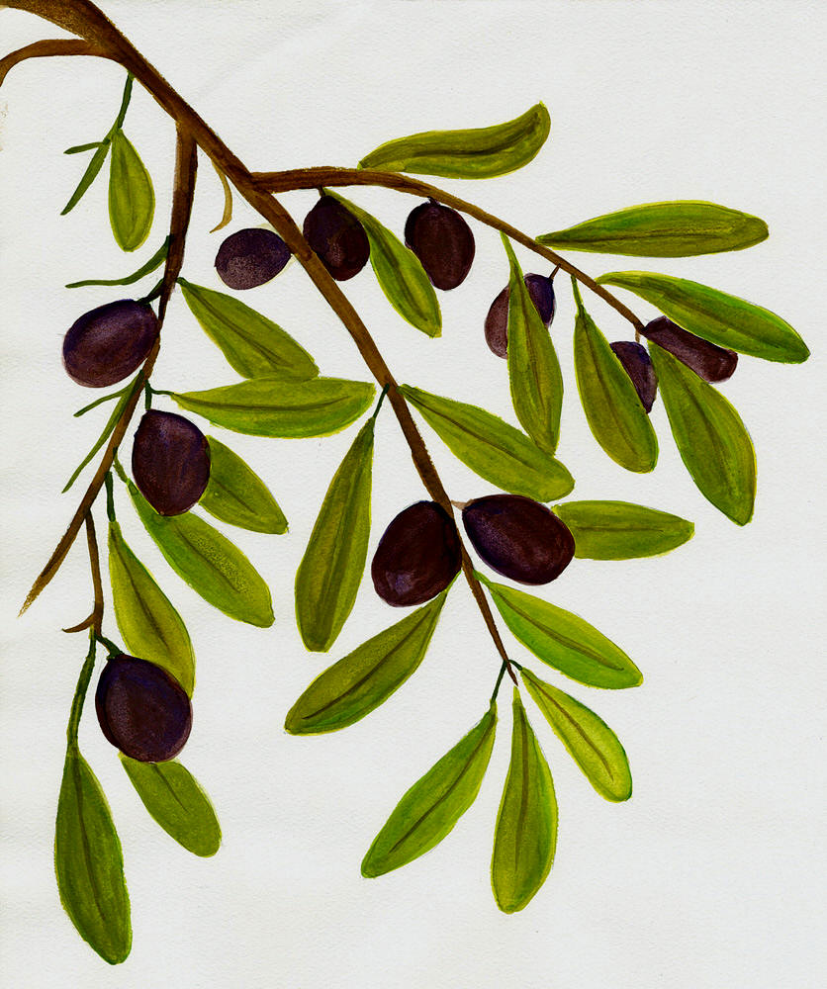

RIVER CROSSING

August 5th 2018

**For Your Daily Prayers**

**New Concerns**

**Zoie Beckett, Siggy McCallum,** **Antoinette McClanahan, Cassidy Meadows Family, Evelyn Surprise, Dolores & Wayne Teem**; Lois Smith.

**On-going Concerns**

Tina Amenta, Peggy Ashton, Pat Bell, Paul & Grace Bernhard, Susan Brady,Lorrie, Phillip, Greg & Stinson Brock,Emelie Brown, Don & Gloria Coon, Lori Cooper, Preston Cryan, Barb & Bob Derflinger,Barbara Driver, Baxter Duddy,Tamara & Rebecca Espinoza,Don Forrester, Sr., Xander Foy, Steven Garza, Bertie Geci, Jeffrey Gotreaux, Diane White Hartley, Alan Herrington, Ann Holden, David Innocente, Don & Jean Johnson, Harrison Jones, Mark Jones, Lynn Kosick, Paul Lorenc, Jenny Lott, Kim Moore, Brandie Niolon, Smith Paterson, Diane Geci Reitz, Courtney Reynolds, Carol Rupp, Tabatha Slaughter, Leland Stewart, John Taylor, Pete & Virginia Totsch, Billy Walker, Jody Ward, Anna Woodard.

**Other Concerns:**

Military & Families, Government leaders at all levels.

Victims: of injustice,

of natural disasters,

of domestic and child abuse.

.

**Marlow United Methodist Church**

**16149 CR 9**

**Summerdale, AL 36580**

**251 988 8563**

**Rev. Sarah Jones – 334-494-6917**

[marlowumc.](http://www.marlowumc.)org facebook.com/marlowumc

**News & Announcements**

**TODAY - OUR COMMUNION OFFERING** will benefit the family of baby Harrison Jones, parents Rachel and Bryan, and big sister, Sarah.

~You can continue to bring frozen casseroles to the church freezer for delivery to the family.

**CHOIR MEMBERS:** Please see Laura Bodenmann right after worship service **today** for a very short meeting about choir. Choir practice-Sunday, August 19, 5 pm.

**TODAY - AN EVENT FOR YOU TO PARTICIPATE IN OUR CONFERENCE-BAYPINES DISTRICT TOWN HALL MEETING.** Bishop David Graves, resident Bishop of the Alabama-West Florida Conference, will hold a Town Hall Meeting **today at 3:00 pm at Bay Minette FUMC**. The church address is 120 W 2nd street, Bay Minette, AL. Please take advantage of this opportunity to visit with our Bishop here in the Baypines District.

The conversation will be about the Commission on the Way Forward. There will be a Q&A time with the Bishop. There won’t be any voting, this is strictly conversational, no decision-making.

**NEXT SUNDAY, AUGUST 12 AFTER WORSHIP “BACK TO SCHOOL WATER BASH”** Bring your swimsuit or play clothes and super soakers for a fun time with water balloons, sprinklers, bubbles and more. Pizza lunch will be served. Don’t forget your towel! Come and join the fun!

**MISSION PROJECT FOR AUGUST:** We are collecting school supplies for the Summerdale school. They need: Copy Paper, Kleenex, Clorox Wipes, Anti- Bacterial Spray (Lysol), & Paper Towels.

**SPIRITUAL ENRICHMENT OPPORTUNITIES:** New studies are starting in:

“Sisters in Christ” Ladies meet on Tuesdays at 10:00 – “*The Way of Grace”*

“Claim Stakers” SS school class-Sundays at 8:45 – for both men and women.

**SUNDAY, AUGUST 26, 3:00-5:00 pm**: “Christmas in August” kids activities – we will have music, craft, snack and games. We will work on our Christmas program music. See Laura Bodenmann for more information.

**PASTOR SARAH’S OFFICE HOURS ARE;** Monday – Thursday, 9:00 am -12:00.

**PUBLICITY:**  Babbie is doing an excellent job in publicizing our activities thru local magazines, newspapers, and radio stations. Please turn in any information by NOON ON MONDAY to Babbie Heilmeier. E-mail is the preferred way, babbie@amcgulfcoast.com. Or you may call: 251-752-7387.

**OUR RIVER CROSSING FOOD PANTRY** needs your continued support. Please donate non-perishable food and place in the container in vestibule.

**CELEBRATION OF LIFE** for DARLENE OLSEN will be August 18th.

**Marlow**

United

Methodist

**Church**

Kingdom

Tide

***Worship with us, where the river bends, where the waters divide the world, where God is calling us beyond.***

***Sit and wait with us, until the drift breaks loose your strain, until your sins flow out to the sea,***

***until Christ lifts you up.***

***Cross over with us! In this place the Spirit stirs the deep;***

***the Way is open, and we cannot stay.***