Daily Prayer Guide

New Concerns: Bev Coon, Sarah Moore and Family of Stacey Posey, All those affected by earthquakes in Venezuela and wildfires in the Western United States. Ted Johnson, Family of Judy Kennedy, John Thomas

On-going Concerns; Bonnie Anderson, Dottie Beaver, Jim Beery, Katrina Blair, Clarence Bodenmann, Margie Bowden, Nancy Boyer, Pamela Mikkelsen Brown, Cele Butler & John Rodgers, Ellen Cailler, Carl Cailler, Jane Capsis, Ron Carder, John Carlisle, Neil Carlson, Zack Carlson, Tami Chrisman, Gary & Cindi Collins, Earl & Debbie Conway, Don & Gloria Coon, Lori Cooper, Mark & Brenda Cooper, Pat Coston, Eddie Cryder, Katie DeRoche,. Forrester Family, Mike & Becky Frolik, Emma, Jade & Darren Gardner, Chuck Garland & Kelli Faidley, Marilyn Goulding, Susan Granade, Anna Woodard Harris, Samantha Harris, John Heronime, Pam Hill, Bette Hollingsworth, Phyllis Horne, Georgia Huffman, Sam Johnson, Sylvia Klaus, Daniel Langley, Brenda Lee, John & JoAnn Liggett, Shane Lindsey, Veme Lockard, Charlotte Locklear, Barb Lorenc, Gail Lovett, DeLynne Luckey, Sam Luckey & Family, Jenny Lundholm, Lee Marshall, Harold McCallum, Madonna McGarry, Fred & Ramona Merrill, Mary Ann Miller, Walter Mixon, Evelyn Mohr, Peggy Overstreet Montgomery, Buddy Moore, Bill Newman, Barb Parella, James Petish, Rick Piper, Linda Poole, Leila Raber, Courtney Reynolds, Richard Riddle, Adalina Rios, Frances Rios, Lupe Rios, Joyce Rochford, Ed & Janet Roy, Jennifer Portman Scott, Jennifer Simmons, Lois Smith, Gunnar Straus, Shannon Sullivan, Colette Suprise, Wayne Teem, Katelyn Tillman, Skip VanAntwerp, Kate Waldron, Cathy Weeks, Eileen White, Karen White

Special Thanks to Those Who Serve
Pastor: Rev. Katy Pass
Instrumentalist/Pian: Laura Bodenmann
Ushers/Greeters: John & Carla Thomas
Worship Leader: Katie Warren
Communion Servers: John & Carla Thomas, Katie Warren
Digital Media: Joanna Hanson-Lundholm

Thinking about joining Marlow United Methodist Church?
Email: marlowum@@gulftel.com
Office Phone: (251)988-8563
Office Hours: Mon–Thurs 9:00 am -12:00 noon

Welcome
to
Marlow United Methodist Church
at
The River Crossing
July 12, 2026
Seventh Sunday after Pentecost

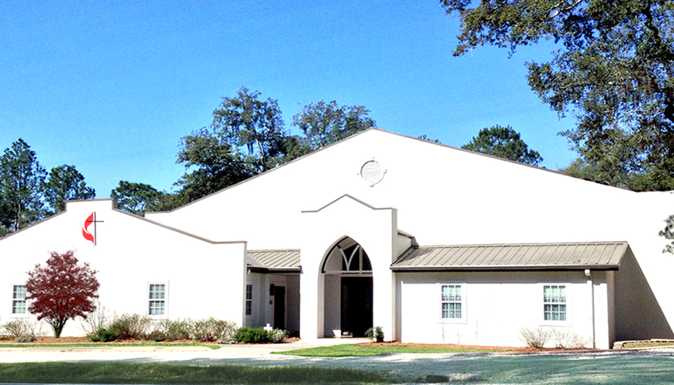

NEWS & ANNOUNCEMENTS

Tues 7/14 Men’s Coffee–Sharing- 7:00 am
Devotional / Prayer Time 7:30 am
Sisters in Christ Fellowship Time 9:30 am
Bible Study 10:00 am
Sun 7/19 Welcome luncheon honoring Pastor Katy Pass 11:15 am

POTLUCK LUNCHEON: We will have a potluck luncheon immediately following Sunday service on July 19th to welcome our new pastor Rev. Katy Pass. The church will provide the meat. Please bring a side dish or dessert to share.

WELCOME VISITORS: If you are visiting with us today, WELCOME!
We are happy to have you with us! We have a welcome gift for you. If you have not already received it, please see one of the usher/greeters. Please fill out the visitor card and place it in the offering plate.

Our Faithfulness week of July 5, 2026

Attendance: 30
Tithes & Offerings $ 1,080.00
Coffee Fund 61.00
Upper Room 5 .00
Helping Hands 10.00
Narcotics Anonymous 60.00
Love Offering 300.00

Ways to Give/Keep up with us on Social Media:



Seventh Sunday after Pentecost
July 12, 2026

PRELUDE

WELCOME AND ANNOUNCEMENTS Katie Warren
*CALL TO WORSHIP On Screen
*HYMN Let Us Break Bread Together, vs.1,3 UMH 618
*AFFIRMATION OF FAITH Apostles’ Creed On Screen
OFFERING
*DOXOLOGY Praise God from Whom All Blessings Flow On Screen
*HYMN Alas, and Did My Savior Bleed, vs.1,5 UMH 359
*SCRIPTURE READING Romans 8:1-11
SERMON “A Fresh Start” Rev. Katy Pass

PASTORAL PRAYER

THE LORD’S PRAYER On Screen
HOLY COMMUNION
*CLOSING HYMN Trust and Obey, vs.1,2,4 UMH 467
*BENEDICTION


*Please stand as you are able

